**Part one:**

1. How many records does the file contain? How many fields are there per record?
   1. 7 records, 5 fields
2. What problem would you encounter if you wanted to produce a listing by city? How would you sole this problem by altering the file structure?
   1. You would have to parse the text to find the city and when doing that you could get bad info if a street name is the same as a city. You should put all parts of the address in its own field.
   2. Street field
   3. Town field
   4. State field
   5. Zip code field
3. What data redundancies do you detect? How could those redundancies lead to anomalies?
   1. Holly 3 times, George 2 times. All of there information is the same. In your data you might find that you have 7 customers but really you have 4.

**Part two:**

Using your school’s student information system, print your class schedule. The schedule probably would contain the student identification number, student name, class code, class name, class credit hours, class instructor name, the class meeting days and times, and the class room number. Use **Figure P1.11** as a template to complete the following actions.

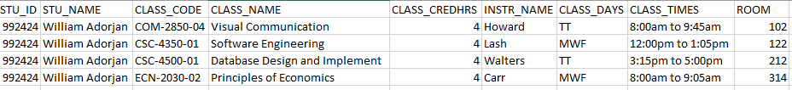

The redundancies are that student info you will have a students information entered as many times as they have classes. There is no way to search by last name without parsing the name box. The class times box is practically a text box. Maybe there should be a start time and end time in two separate fields. There is no building ID just room number so you can search the room but you have no clue what building it is in. The class code has 3 different parts subject, class id and section of class these could be separated into different fields. I also know that sometimes it might be smart to reference two different tables or databases to cut down on redundancies. You do not need the students first name to know they are in a class you could just reference their unique student ID.

The time box is unclear what number is a start time or end time. If you were to parse this box you could get false positives because the end time is the same time as a start time you were looking for. In this case maybe it would be smart to assign class times to a number so class time 1 is 8 to 9:05 on MWF then you can get multiple info done at the same time. You would have to get data from multiple different databases but it would make this specific database clearer. I do not think that this data format makes any sense if you were to put every student in this database. It could be smarter to have a student database and then reference them to a class database for the classes they are in. That class database would only have its own properties and a list of students in the class.